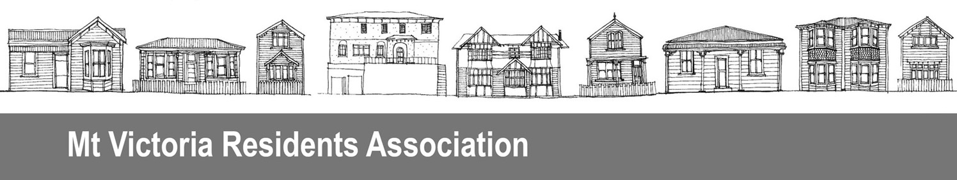
PO Box 19056, Wellington 6149

11 February 2016

Contact: Craig Palmer, President
29 Moir St, Mt Victoria, Wellington 6011
Phone: (04) 384 2127
Email: palmerspring@actrix.co.nz

Wellington International Airport Ltd and
Wellington City Council
Sent via Connect Wellington website http://www.connectwellington.co.nz/ and
Email: info@wcc.govt.nz

Submission on proposed Wellington airport runway extension
The Mt Victoria Residents’ Association Incorporated is a local community group whose objectives include to contribute to the wellbeing of residents. Our activities support and are in line with the Wellington City Council’s stated community outcomes, a people-centred city, an eco-city, a connected city, and a dynamic central city.
We have considered the reports presented on the Connect Wellington website. Despite the large number of reports, including economic analyses, not one appears to clearly set out exactly what the real accounting costs are, and who will pay them.
We continue to strongly oppose the spending by the Wellington City Council of $90 million on the airport runway extension. We have already advised the Council of our opposition in our submissions on the 2015-25 Long Term Plan and the 2016-17 Annual Plan.
Our reasons for opposing are:
- The Wellington community will take on a significant debt burden and the costs of servicing it, while the benefits go mostly to private interests. The beneficiaries will include businesses from access to overseas markets, meetings and investors, and from spending by overseas visitors, overseas visitors themselves, Infratil from increased returns for little cost, and Wellingtonians travelling overseas.
- The problem statement in the cost benefit analysis report states the runway’s restricted length imposes an economic cost to the nation as a whole. If that is so, why are Wellington city ratepayers paying so much of the cost?
- Infratil owns 66% of the airport and yet is reported to be investing on $40-50 million. If the extension is as good an idea as the Connect Wellington marketing suggests, why isn’t the majority owner not investing the majority of the money?
- Central government, and other Wellington region councils have not shown great support, particularly on helping fund the extension.
- The proposal is not supported by the airline industry itself (BARNZ). Currently, several airlines fly directly from Wellington to Australian cities and Pacific islands. These airlines and others see Auckland as the long-haul hub for New Zealand, and it is doubtful that will change.
- Long-haul demand from the immediate Wellington catchment in 2014 was only 420 passengers per day each way, and so the forecast passenger growth is heavily reliant on overseas visitors wanting to come directly to Wellington and to leave from here. It is dubious that there will be sufficient passengers for three to four flights a week each to Singapore, Hong Kong, Los Angeles, and Kuala Lumpur.

