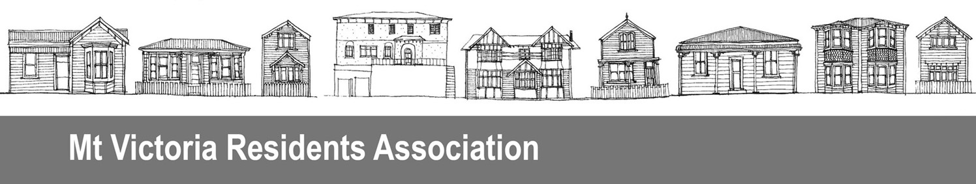
PO Box 19056, Wellington 6011
Date 16 July 2016

Contact Craig Palmer
President, Mt Victoria Residents Association
Phone 04 385 0366
Email mtvicra@gmail.com

Draft Open Space Access Plan
Parks, Sport and Recreation
Wellington City Council
PO Box 2199, Wellington 6140
Email: accessplan@wcc.govt.nz

Submission on Open Spaces Access Plan
The Mt Victoria Residents’ Association Inc is an active advocate on behalf of the Mt Victoria community, aiming to further the interests of our neighbourhood with local and central government.

We would like to be heard in support of our submission.

The Mt Victoria part of the Town Belt is a significant asset for residents in this otherwise densely populated urban area. We value being able to easily access the park, particularly for walking, and there is a significant minority of people who enjoy walking their dogs in our park. There are even a small number of people who enjoy mountain biking here. It would be useful if the survey information on park users had been included with these proposals to inform dicussion.

We note that some of the proposals in this document have already been implemented, e.g mountainbike-only pathway signage on Mt Victoria. We question the sincerity of seeking public consultation on proposals when the actions have already been taken. This is a significant departure from the status quo of all paths being shared (which itself was a significant departure from the previous regime of walk-only paths).We are concerned that a list of bike only tracks has been developed without wider consultation with the public or Mt Victoria residents. The Mt Victoria Master Plan had extensive consultation and this list was not part of that work. The Mt Victoria Residents’ Association would have appreciated being part of this work and would have strongly advocated for at least an equal number of walk only tracks on our intensively used park.

The implementation plan outlines different grades of track (page 1) however it is unclear in the plan what type of tracks are being proposed in each area as this is not specified.

Commuter links

The implementation plan includes planning to investigate opportunities to develop more formalised commuter link tracks through the open space network egHataitai to City track via Mount Victoria / Matairangi (potential to fund this via Transport initiatives). Commuter links through the Town Belt are forbidden under current rules, including the Town Belt Deed 1873wherebyno thoroughfare is to be built, and where the Town Belt is to remain as a predominantly natural area in contrast to the built up urban space for recreational purposes. The status quo should remain. We do not support creating commuter routes through the Mt Victoria Town Belt, includingon the Hataitai to Mt Victoria track or on the Newtown to Mt Victoria track (which is currently being upgraded for walking we thought) .

Electric motorbikes

We do not support the proposal to allow motorbikes (however powered) into our Open Spaces, or a 25km hour speed limit. High use walking tracks and parks are not suitable places to encourage electric motorbikes.Many of the electric motorbikes now being used on the roads should not be used in our parks. They are too fast and too intrusive. This detracts from the experience of all users who ‘get there’ under their own steam. The Getting Everyone Active and Healthy, a key outcome of Our Capital Spaces – An Open Spaces and Recreation Framework For Wellington: 2013–23 - supports healthy activity not motorised leisure.

Should motorcyclists want to get from Newtown to Mt Victoria there is a well developed road network they can use. In addition, Makara Mountain Bike park has been specifically created from our park space for use by bikes and this should be the only space for motorbike users who insist on going off road.

Electric motorbikes are poorly regulated nationally and it is very difficult to ascertain if the 300 watt rating has been exceeded, or if a bike is electric-assisted (ie the cyclist must pedal at all times) or not. We also question who is going to monitor electric motorbike use to ensure compliance, and what will the consequences be of non-compliance. We recommend the Council advocates to central government that the rules around electric motorbikes are strengthened as a matter of urgency. Advocacy should include ease of enforcement, and use of roads by other users as a key considereation in electric motorbike regulation.

Bike only tracks

The proposal to allow some bike-only tracks is not supported. We note the implementation plan specifically states all tracks will be shared.

We support making further tracks walk-only – particularly the Southern Walkway, the Lookout Walkway, and all the smaller third tier tracks (they are too narrow for cyclists to use safely with walkers). The list of walk-only tracks is very limited and in areas that are not suitable for vehicle use in any case, and needs significant extension for the majority of open space users who are on foot.

We are concerned over the intersections of bike-only tracks, which encourage high speed downhill riding, with walkers on tracks. We urge that some slowing measures are installed near intersections so bikers are made aware of the need to consider walkers. We also note that bike-only tracksare encouraging groups of bikers to repeatedly access the summit by car so they can hurtle down Mt Victoria and Majoribanks Sreet. They are then met by the car at Hawker Street and taken back up to the summit.

The ‘nature trail’ to be developed on Mt Victoria near Alexandra Road specifically for children appears to be being made as another cycle track. This is inappropriate and people including children will not be able to enjoy ‘nature’ with others hurtling past on bikes.

Paper roads

Paper roads can be useful for providing access to some areas but this needs to be coordinated within the overall plan for an area.

Other matters

We recommend that Alexandra Road is made a 30 km hour speed zone which would be suitable for all bike riders including electric motorbikes. This would enhance the park experience for all users particularly walkers crossing this road.

We note while the Mt Victoria Master Plan gives priority to upgrade the Southern Walkway and Lookout track, work seems to be prioritised in other areas. Can we please see some coordination so that the identified priorities are in fact done first.

This proposed Open Access Plan needs to incorporate reference to the Mt Victoria Master Plan.

