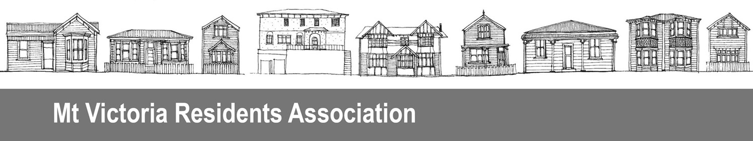
PO Box 19056, Wellington 6011
Date 12 August 2016

Contact Craig Palmer
President, Mt Victoria Residents Association
Phone 04 385 0366
Email mtvicra@gmail.com

Greater Wellington Regional Council, and
Wellington City Council
Email: notifications@gw.govt.nz
Submission on Wellington airport runway extension – resource consent application
The Mt Victoria Residents’ Association Incorporated (MVRA) is an active advocate on behalf of the Mt Victoria community, aiming to further the interests of our neighbourhood with local and central government. Our activities support and are in line with the Wellington City Council’s stated community outcomes, a people-centred city, an eco-city, a connected city, and a dynamic central city.

We would like to be heard in support of our submission.

The MVRA opposes the resource consent for a proposed extension of the Wellington airport runway in its entirety. The reasons MVRA oppose the consent being granted is because it will not achieve the purposes of the Resource Management Act to:
- promote the sustainable management of natural and physical resources
- enable people and communities to provide for their social, economic, and cultural well-being and for their health and safety

sustain the potential of natural and physical resources to meet the reasonably foreseeable needs of future generations

safeguard the life-supporting capacity of air, water, soil, and ecosystems

avoid, remedy, or mitigate any adverse effects of activities on the environment

MVRA oppose the consent being granted as there has not been sufficient assessment of alternatives to the proposal.
MVRA has concerns in particular that the economic well being of our community will be adversely affected by the poor business case for this initiative:
- The cost-benefit analysis exaggerates the benefits as per NZIER critique for BRANZ in Feb 16 – After Adjusting the Sapere analysis to account for over-optimism reduces the BCR to below 1.0 Under all but the most optimistic assumptions the runway extension is a wasteful investment for NZ taxpayers and a drain on the national economy.
- The Wellington community will take on a significant debt burden and the costs of servicing it, while the benefits go mostly to private interests. The beneficiaries will include businesses from access to overseas markets, meetings and investors, and from spending by overseas visitors, overseas visitors themselves, Infratil from increased returns for little cost, and Wellingtonians travelling overseas.
- The problem statement in the cost benefit analysis report states the runway’s restricted length imposes an economic cost to the nation as a whole. If that is so, why are Wellington city ratepayers paying so much of the cost? Infratil owns 66% of the airport and yet is reported to be investing only $40-50 million. If the extension is as good an idea as the Connect Wellington marketing suggests, why isn’t the majority owner not investing the majority of the money?
- Central government, and other Wellington region councils have not shown great support, particularly on helping fund the extension.
- The proposal is not supported by the airline industry itself (BARNZ). Currently, several airlines fly directly from Wellington to Australian cities and Pacific islands. These airlines and others see Auckland as the long-haul hub for New Zealand, and it is doubtful that will change.
- Long-haul demand from the immediate Wellington catchment in 2014 was only 420 passengers per day each way, and so the forecast passenger growth is heavily reliant on overseas visitors wanting to come directly to Wellington and to leave from here. It is dubious that there will be sufficient passengers for three to four flights a week each to Singapore, Hong Kong, Los Angeles, and Kuala Lumpur.

MVRA has concerns that the environmental effects of this proposal have not and can not be adequately mitigated in particular:

- The effect on the local coastal marine ecosystems and coastal processes
- The impact on climate change matters from the expected increase in air traffic both on unsustainable travel patterns and air quality
- The increased noise levels of larger and more frequent planes. Noise from the airport is already appreciable even in Mount Victoria.

MVRA has concerns about the construction impacts of this proposal on our neighbourhood and the wider city, in particular

- The increase in heavy trucks over several years both on safety of other road users and air quality and noise issues.

MVRA has concerns that even if this runway extension is built it will not materially improve the safety at the airport and is therefore not a sustainable use of resources. The NZ Pilots Association point out the current 90metres at each end is the minimum allowed under Part 139 of the Civil Aviation Rules – they recommend 240m, but the extension will still have only 90metres.

