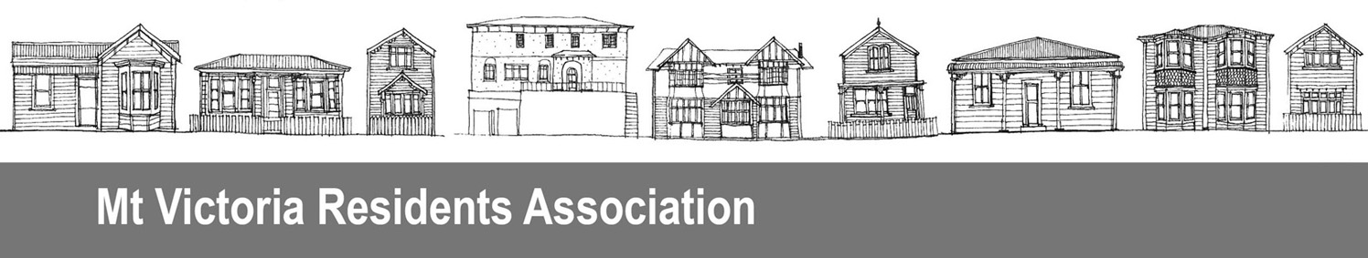
PO Box 19056, Wellington 6011
Contact Ellen Blake
Member, Mt Victoria Residents Association
Phone 021 1067139
Date 29 February 2016
Submission on Traffic Resolution 17-16 Hawker Street
We support the change to the traffic resolution to match what is actually shown on the sign on Hawker Street. We think this is a very sensible approach in an area where no issues have been identified.

The Mt Victoria Residents Association is an active advocate on behalf of the Mt Victoria community, aiming to further the interests of our neighbourhood with local and central government.

