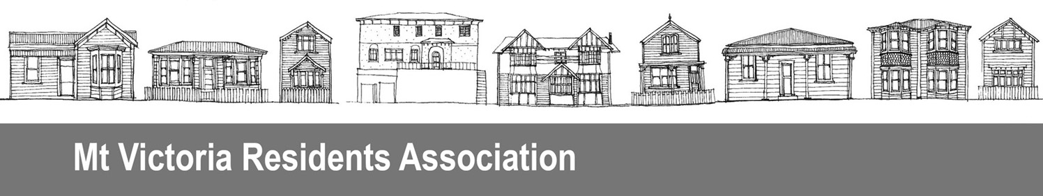

29 July 2016

Committee Secretariat
Government Administration
Parliament Buildings
Wellington
Email: select.committees@parliament.govt.nz

This submission is from an organisation, the Mount Victoria Residents’ Association Inc.

The Association can be contacted through:
Craig Palmer, President
29 Moir St, Mt Victoria
Wellington 6011
Email: mtvicra@gmail.com
Phone: 04 384 2127

We do not wish to appear before the committee to speak to our submission.

Submission on the Charities Amendment Bill

The Mount Victoria Residents’ Association Inc (the MVRA) welcomes the opportunity to comment on proposed amendments to the Charities Act 2005 (the Act) and submits the following on the Charities Amendment Bill (the Bill).

The Association is an Incorporated Society and is registered as a charity with the Charities Commission.

Clause 13 amending section 61 Determination of appeal

This clause will delete “of the chief executive” from section 61(1)(a).

Comment
We agree that as section 61 currently sits under a heading “Appeals against decisions of Board” it does not include decisions made by the chief executive.

However, the current Act contains no right of appeal against decisions of the chief executive, and we suggest it should. The chief executive can exercise powers delegated to her/him by the board and is also given powers by the Act. A person who is aggrieved by a decision of the chief executive should have the right to appeal the decision in the same way the person can appeal a board decision.

We recommend that:
- A new clause is added to the Bill to amend the heading preceding section 59 so it reads “Appeals against decisions of Board and chief executive”
- A new clause is added to amend section 59 so where it states “the Board” that should be amended to “the Board and chief executive”
- Clause 13 is deleted.

