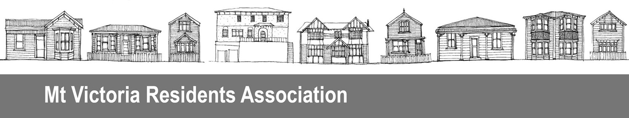
PO Box 19056, Wellington 6149

7 December 2015

Contact: Craig Palmer, President
29 Moir St, Mt Victoria, Wellington 6011
Phone: (04) 384 2127
Email: palmerspring@actrix.co.nz

Manager of Open Space and Recreation Planning
Wellington City Council
PO Box 2199, Wellington 6140
Email: Michael.Oates@wcc.govt.nz

Submission on proposed land exchange at St Gerard’s Monastery

The Mt Victoria Residents’ Association Inc has recently made a joint submission with the Oriental Bay Residents’ Association suggesting the whole St Gerard’s Monastery Reserve and Oriental Terrace public area should be managed as an integrated whole. We also suggested some improvements to make the area more inviting and accessible to its users and visitors. These matters have now been put in abeyance pending the outcome of the proposed land exchange.

We would like to make an oral submission to City Councillors.

We note the exchange will give the Council a permanent pedestrian access to Oriental Terrace via the existing pathway where the land is currently owned by the Institute for World Evangelisation (ICPE). The ICPE will gain the strip of Council land alongside its property at 1 Oriental Terrace. Although it is not mentioned in your letter to us of 20 October 2015 or in the public invitation to make submissions, we understand the exchange will increase the value of the property at 1 Oriental Terrace for potential sale to raise money for the earthquake-strengthening of St Gerard’s. This could potentially save the Council from providing financial assistance for its strengthening. But there is apparently no guarantee that is how the money will be used.

We are very concerned that, if 1 Oriental Terrace is sold, it could be removed and replaced by an inappropriate development that would be out of character with its neighbours, including those within the Mt Victoria Design Guide area to the south. Its height could also obscure views of the Monastery from Oriental Bay, and site coverage and bulk dominate the Monastery Reserve and Monastery itself.

In addition, nothing is stated about what happens if the exchange does not proceed. Will the Council be able to continue having a pathway over the ICPE land? Or will it have to build a new pathway to Oriental Terrace on its own land? It also appears there is nothing to prevent the ICPE from selling 1 Oriental Terrace now.

On site, there is the current pathway, a steep bank between it and 1 Oriental Terrace, and a large, weed-covered piece of land at the Oriental Terrace end which appears to be part of the ICPE land. It is impossible to determine exactly what is being exchanged because the boundaries are unclear. We suggest a site visit for interested submitters to peg out the pieces of land under discussion.

At this stage we do not support the land exchange because there is insufficient information provided, including on what the status quo and land exchange options would mean for both parties, and to identify the boundaries of the two pieces of land to be exchanged.

If the Council decides to proceed, we urge that it place conditions on any development of the 1 Oriental Terrace property, including limits on height, site coverage/bulk, character of design, and sunlight planes.

