FOR OFFICE USE ONLY


Submitter ID:

File No:


Further Submission

on Proposed Natural Resources Plan for the Wellington Region

Clause 8 of Schedule 1, Resource Management Act 1991.

Please complete this form to make a further submission on the Proposed Natural Resources Plan for the Wellington Region (PNRP). All sections of this form need to be completed for the submission to be accepted.

A further submission may only be made by a person representing a relevant aspect of the public interest, or a person that has an interest in the PNRP greater than the interest that the general public has, or the Wellington Regional Council itself. A further submission must be limited to a matter in support of, or in opposition to, a submission made on the PNRP.

For information on making a further submission see the Ministry for the Environment website: www.mfe.govt.nz/publications/rma/everyday-guide-rma-making-submission-about-proposed-plan-or-plan-change

Return your signed further submission to the Wellington Regional Council by post or email by 5pm Tuesday 29 March 2016 to:

Greater Wellington Regional Council | Regionalplan@gw.govt.nz
Further Submission on Proposed Natural Resources Plan
for the Wellington Region
Freepost 3156
PO Box 11646
Manners Street
Wellington 6142

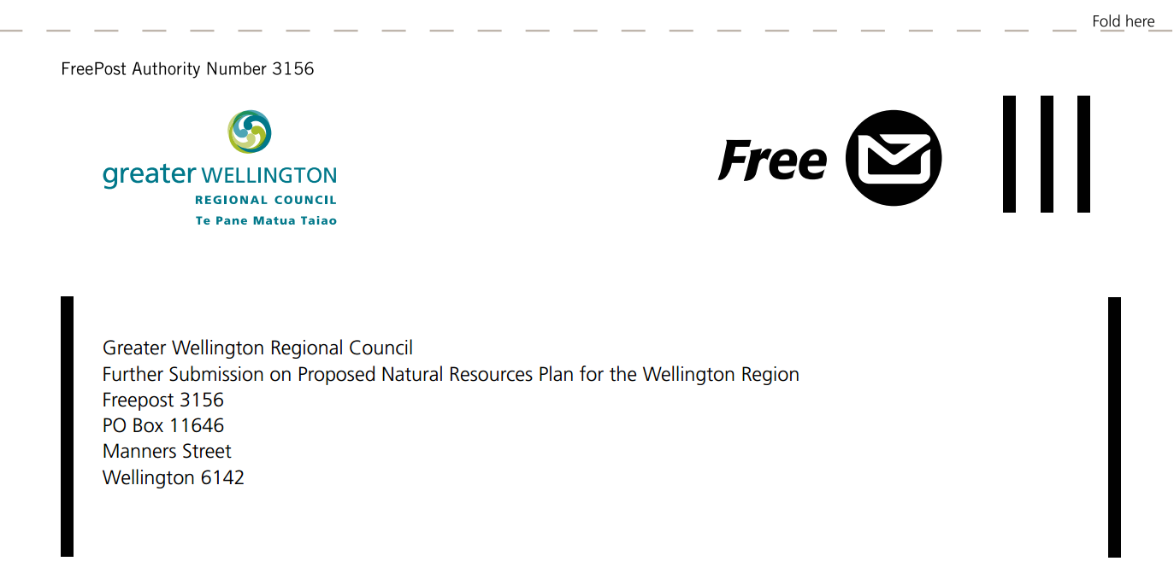

FORM 6: FURTHER SUBMISSION FORM

This is a further submission in support of, or opposition to, a submission on the PNRP.

A. DETAILS OF FURTHER SUBMITTER

FULL NAME
ORGANISATION (*the organisation that this submission is made on behalf of)
ADDRESS FOR SERVICE (INCLUDING POSTCODE)
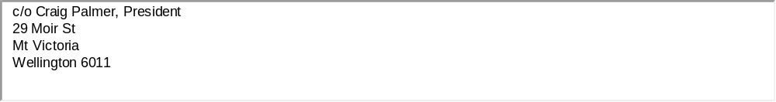

PHONE FAX
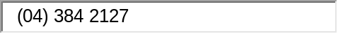

EMAIL
.
Only certain people may make further submissions

Please tick the option that applies to you:

I am a person representing a relevant aspect of the public interest; or

I am a person who has an interest in the PNRP that is greater than the interest the general public has.

Specify below the grounds for saying that you are within the category you have ticked.
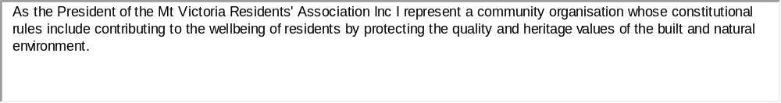

Service of your further submission

Please note that you must serve a copy of this further submission on the original submitter no later than five working days afterthis further submission has been provided to Wellington Regional Council.

If you have made a further submission on a number of original submissions, then copies of your further submission will need to be served on each original submitter.

Signature: Date:

Signature of person making further submission or person authorised to sign on behalf of person making the further submission. A signature is not required if you make your submission by electronic means.

Please note

All information contained in a further submission under the Resource Management Act 1991 becomes public information. All further submissions will be put on our website and will include all personal details included in the further submission.

B. APPEARANCE AT HEARING

Please select from the following:

I do not wish to be heard in support of my further submission; or

I do wish to be heard in support of my further submission; and, if so,

I would be prepared to consider presenting this further submission in a joint case with others making a similar further submission at any hearing.

Please enter further submission points in the table on the following pages

C. FURTHER SUBMISSION POINTS

Please complete the following table with details of which original submission points you support and/or oppose, and why, adding further rows as necessary.

Details of the  submission you are  commenting on  Name of person/  group making  original submission  and postal address. | Original  submission  number  The original  submission  number can  be found on  the submitter  address list. | Position  Whether you  support or  oppose the  submission. | Part(s) of the submission  you support or oppose  Indicate which parts of  the original submission  (which submission points)  you support or oppose,  together with any  relevant PNRP provisions. | Reasons  Why you support  or oppose each  submission point. | Relief sought  The part or whole of  each submission point  you wish to be allowed  or disallowed.
e.g.  Joanne Bloggs  12 Pine Tree Avenue  Redwood | e.g.  submitter S102 | e.g.  Oppose | e.g.  Oppose all of submission point  S102/41 | e.g.  The submission point does  not recognise… | e.g.  Disallow the parts of S102/41  relating to…

Porirua City Council | S163/002 | Support | Agree, the further submissions period should be open for an extended duration,not just one month | This will enable full consideration of the wide variety of detailed issues that are raised by submitters | Extend deadline for further submissions
NZ Transport Agency | S146/036 | Support in part | Support part of (e) to include cycling and walking transportation corridors | The definition of “strategic transport network” should include cycling and walking as important parts of transportation infrastructure | Include cycling and walking corridors in definition of “strategic transport network”
Land Matters LTD plus several other submitters | S285/051 | Oppose | Oppose removing any provisions in the entire plan that seek to improve water quality with the exception of those water-bodies that have already been overallocated | It is contrary to ensuring sustainable water quality in general for the future | Do not allow change proposed by submitters
Vector Gas Ltd, NZ Transport Agency and Wellington International Airport Ltd | S145/016, S146/043 & S146/042, and S282/005 | Oppose | Oppose adding new objectives to provide for and recognise that regionally significant infrastructure represents appropriate use and development in all environments where there are functional needs and / or operational requirements | Functional needs and operational requirements of infrastructure should not over-ride more important criteria for determining “appropriate use and development in all environments” .  The key objective of NRP is about protection, enhancement and sustainable use of natural resources, not enabling the kind of activities that impose major burdens on natural resources | Do not allow additions proposed by submitters
Wellington Civic Trust | S62/009 | Support | Support amendment to Objective O57 to add words “...and has particular regard to Objectives O55 and O56” | Use and development must have particular regard to the need for public open space, and be compatible with its maritime location, not the Wellington CBD | Amend policy as suggested by submitter
Heritage New Zealand | S094/004 | Support | Support retaining policies relating to culture and heritage |  | Retain policies as proposed
Wellington City Council | S286/006 | Oppose | Oppose amendment to remove reference to ‘avoid’ in policies | This is a blanket amendment which is inappropriate in many of the 80 cases where some form of the word appears | Do not allow change proposed by submitter
Minister of Conservation | S75/051 | Support | Support retaining Policy P3: precautionary approach as notified |  | Retain policy as notified
NZ Transport Agency | S146/076 | Oppose | Oppose replacement of Policy 4: Minimising adverse effect | Policy 4 should be retained as it makes an important general statement across all aspects of the natural resources plan | Do not allow any changes proposed by this and many other submitters
NZ Transport Agency | S146/110 | Oppose | Oppose amendment to Policy 52: Managing ambient air quality | Requirement to minimise adverse effects should not be diluted | Do not allow change proposed by submitter
Wellington Civic Trust | S62/014 | Support | Support amendment to P59: industrial point source discharges | It is important to add adverse effects on amenity to wording | Amend policy as submitter recommends, and otherwise retain as notified
Wellington Civic Trust | S62/015 | Support | Support amendment to P60: Agrichemicals and fumigants | It is important to add wording re adverse effects on amenity | Amend policy as submitter recommends, and otherwise retain as notified
Rangitane o Wairarapa Inc | S279/161 | Support in part with further amendment | Support amending P142 Lambton Harbour Area so area must be managed to avoid adverse effects on the sites and their associated values. To do that we recommend deleting (b) | P142(b) should be deleted as it is contrary to Objective O56 – use and development should be compatible with the maritime setting in the coastal marine area, not the urban form of the city | Amend policy as recommended

If you require more space for additional comments, please insert new rows as needed

