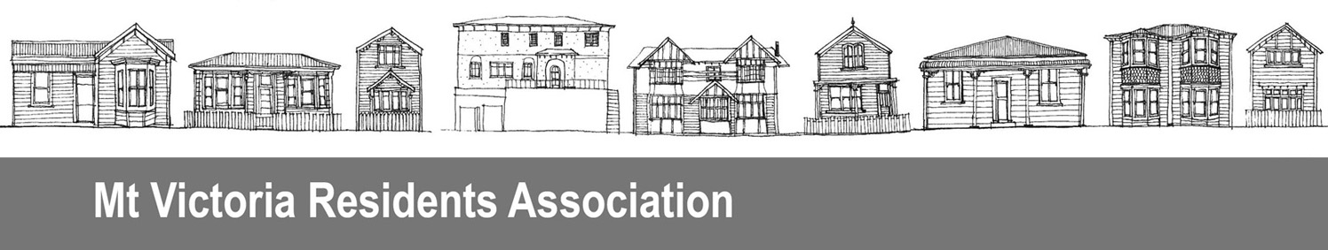
Mt Victoria Residents Association
4 August 2023

Thank you for the opportunity to comment on the community facilties plan.

We support appropriate provision on community facilities spread equitably across the city. We note that there are very few facilities in the central city and inner city suburbs. This indicates that public provision for the inner city should be reviewed.

As the inner city densifies the range of public activity that require public facilities will increase, for instance the simple pleasure of eating outdoors in a backyard will need to occur in a public park or similar, and facilities to do this should be provided.

We note many facilities are located on our public reserves and Town Belt. A requirement to look after the green space and support native biodiversity should be a requirement of any lease arrangement. Old Man’s Beard, other weed species and rubbish have been found on leased sites in Mt Victoria. The leasee should be required to control the weeds and clean up the rubbish.

Similarly there is a need for a requirement that providing services from facilities need to be well managed, for instance a public compost facility in Mt Victoria is associated with odour issues and rats.

The Basin Reserve has not been mentioned in the plan and yet is a key facility on public reserve land.

We ask that provision of these facilities is included in the plan:

1 Mt Victoria Residents Association would like to see a public toilet reinstated at the Pirie Street playground. Toilets are essential facilities for small children and their caregivers to be able to enjoy parks. This could be provided in combination with nearby facilities located on public Town Belt land. The most convenient to the playground would be a joint toilet facility with the Victoria Bowling Club.

2 Mt Victoria is a key emergency hub for residents not only from Mt Victoria but also the inner city and Oriental Bay (a significant number of people). A requirement that public facilities are available during emergencies should be included in lease agreements.

3 We support the Victoria Bowling Club plan and this should include the community and innermost gardens right next door.

Ellen Blake

